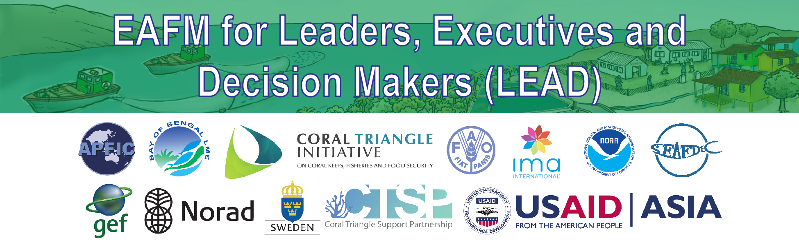

EAFM High-level Consultation for Leaders, Executives and Decision Makers (LEAD)
One-day Consultation

Date, Place

Agenda:
09.00 | I. Opening and introductions | 60 mins
10.00 | II. Threats, issues and vision for the future | 30 mins
10.30 | TEA/COFFEE BREAK and GROUP PHOTO
11.00 | III. Overview of EAFM: What and why of EAFM | 45 mins
11.45 | IV. National roles, responsibilities and existing frameworks | 30 mins
12.15 | LUNCH
13.15 | V. Linking Policies to action and importance of EAFM plans | 25 mins
13.40 | VI. EAFM planning process | 25 mins
14.05 | VII. Policy trade-offs | 25 mins
14.30 | VIII. EAFM governance frameworks | 30 mins
15.00 | TEA/COFFEE BREAK
15.30 | IX. Developing capacity for EAFM | 30 mins
16.00 | X. Next steps and action plans | 45 mins
16.45 | XI. Closing | 15 mins

